**Cover Page**

**CSCI 2272 - Computer Organization and Lab**

**Lab Report 6**

**Student 1 Name and BC Email: Grace Wagner - wagnerge@bc.edu**

**Student 2 Name and BC Email: Jonathan Nushi - nushi@bc.edu**

## Circuit 1

## Design

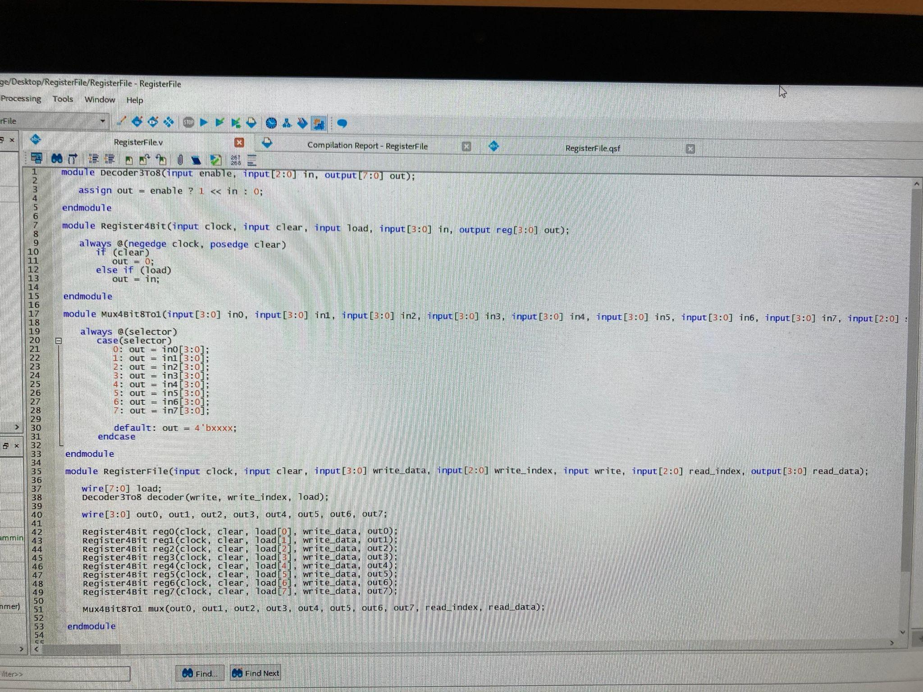

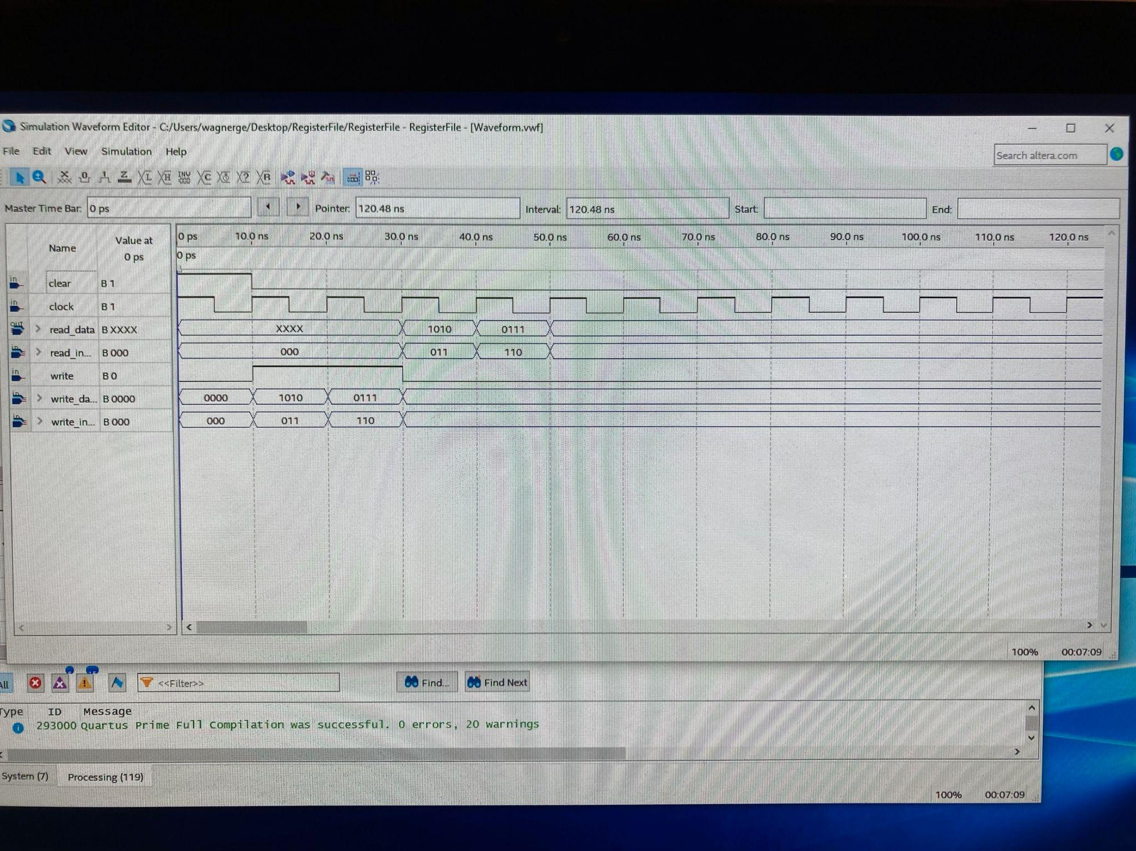

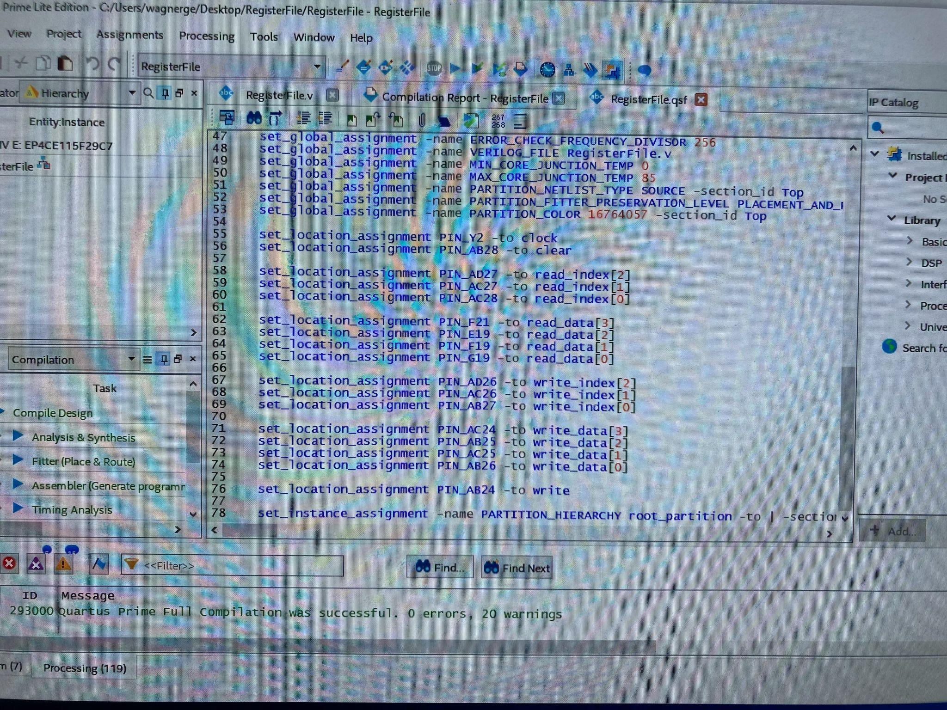

## Output

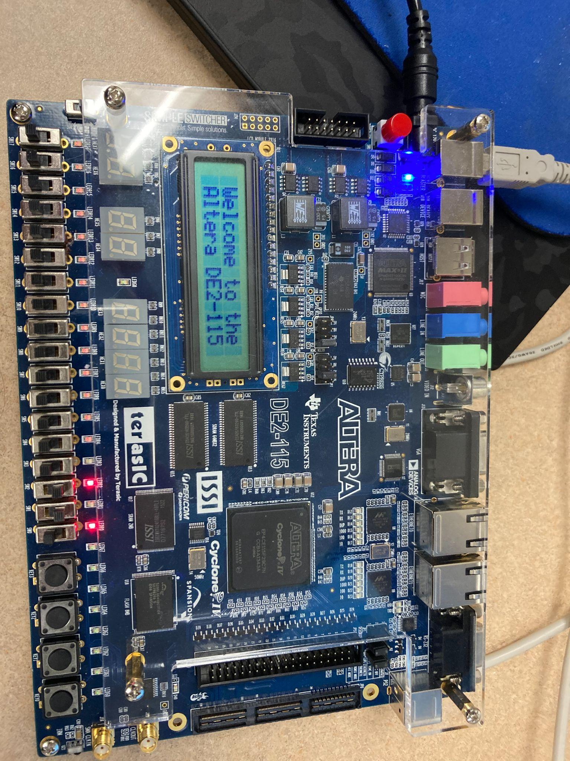

## Reflections

1. What did you learn from this lab?

We learned how to implement an 8x4 register file using verilog code and a waveform simulation.

1. What errors did you face and explain how you resolved them. Feel free to collect screenshots of errors or copy and paste them here?

We had some trouble figuring out how to implement the RegisterFile module, but after analyzing the block diagram and going through some trial and error we figured out how to design it. We also had some trouble figuring out how to operate the board once we set up our switches and pin assignments, but after consulting the TA for help we figured out how to get our desired outputs.

1. What tasks did each of you perform in the lab? Can you say we both did everything together or if you divided tasks amongst yourself or some other way that you used to accomplish this lab?

Jonathan - Reviewed the Verilog code from class and that was written during the lab, read off the times and inputs for the Waveform simulation, read off the pin assignments.

Grace - Wrote the Verilog code, organized the Waveform simulation, entered the pin assignments, operated the Altera board.

1. What reference material did you use for this lab? If it was a resource from the web, please include it here.

We only used the lab guide and the pin assignments provided.